1 The points A and B have coordinates (3k − 4, −2) and (1, k + 1) respectively, where k is a constant. Given that the gradient of AB is
a show that k = 3 (2 marks)
b find an equation of the line through A and B (3 marks)
c find an equation of the perpendicular bisector of A and B, leaving your answer
in the form where a, b and c are integers. (4 marks)
2 a Find an equation of the straight line passing through the points with coordinates
(4, −7) and (−6, 11), giving your answer in the form ,where a, b
and c are integers. (3 marks)
The line crosses the x-axis at point A and the y-axis at point B and O is the origin.
b Find the area of triangle AOB. (3 marks)
3 The line with equation touches the circle with equation
. Find the two possible values of m, giving your answers
in exact form. (7 marks)
4 The equations of two circles are and
a Find the centre and radius of each circle, giving your answers in terms of q
where necessary. (6 marks)
b Given that the distance between the centres of the circles isfind the two
possible values of q. (3 marks)
5 A is the centre of circle C, with equation
P, Q and R are points on the circle and the lines l₁, l₂ and l₃ are tangents to the circle
at these points respectively. Line l₂ intersects line l₁ at B and line l₃ at D.
Figure 1
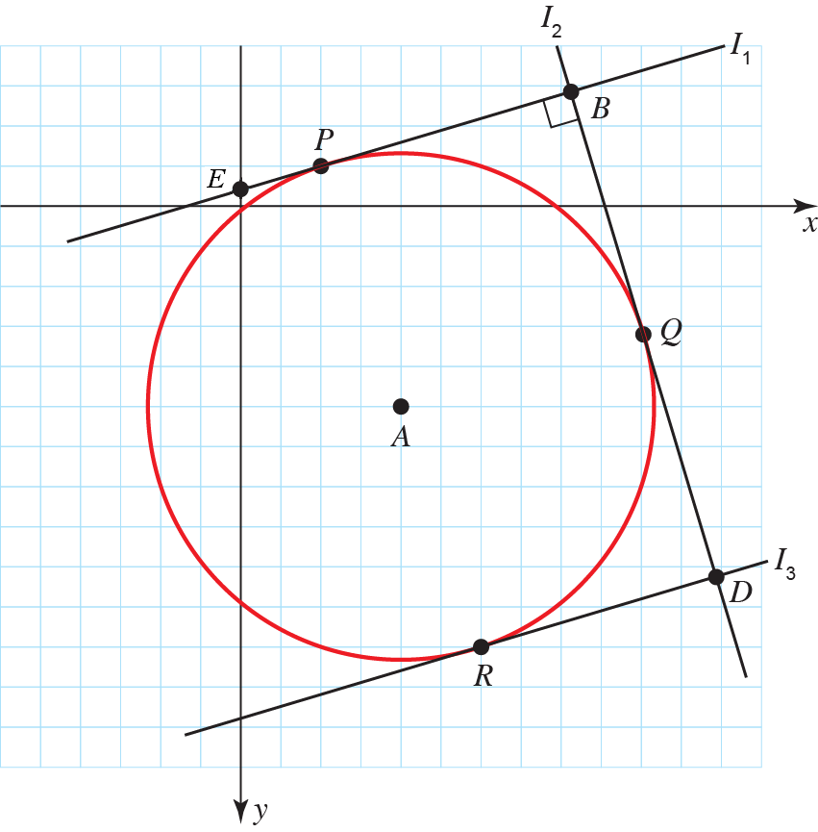
a Find the centre and radius of C. (3 marks)
b Given that the x-coordinate of Q is 10 and that the gradient of AQ is positive,
find the y-coordinate of Q, explaining your solution. (4 marks)
c Find the equation of l₂, giving your answer in the form y = mx + b. (4 marks)
d Given that APBQ is a square, find the equation of l₁ in the form y = mx + b. (4 marks)
intercepts the y-axis at E.
e Find the area of triangle EPA. (4 marks)

