Algebraic Methods Tutorial Questions
Q1.
Express
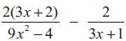
as a single fraction in its simplest form.
(4)
(Total 4 marks)

Q2.
Express 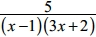 in partial fractions.
(3)

Q3.
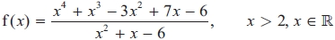
Given that
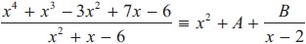
find the values of the constants A and B.
(4)

Q4.
Express
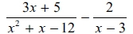
as a single fraction in its simplest form.
(4)
(Total 4 marks)

Q5.

f(x) = 4x³ – 12x² + 2x – 6
(a) Use the factor theorem to show that (x – 3) is a factor of f(x).
(2)
(b) Hence show that 3 is the only real root of the equation f(x) = 0
(4)

(Total for question = 6 marks)

Q6.
Express $\frac{24x^{2}+39x+12}{{(x-1)(3x+2)}^{2}}$ in partial fractions.

Q7.

Given that
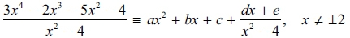
find the values of the constants a, b, c, d and e.
(4)
(Total 4 marks)

Q8.
f(x) = 3x³ + 2ax² – 4x + 5a
Given that (x + 3) is a factor of f(x), find the value of the constant a.

(Total for question = 3 marks)

