A Level Mathematics – Pure
Refer to this handbook when you are completing exam questions
Yr1 Chapter 2: The discriminant  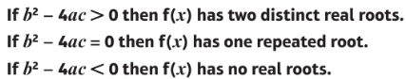 | Yr1 Chapter 4 & Yr2 Chapter 2: Transformations of graphs  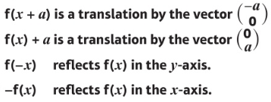  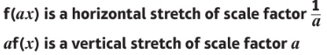
Yr2 Chapter 5: Radians
Arc length: $l=rθ$
Area of sector: $A=\frac{1}{2}r^{2}θ$
Area of segment: $A=\frac{1}{2}r^{2}(θ-sinθ)$
Yr1 Chapter 14: Laws of logarithms  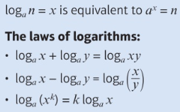  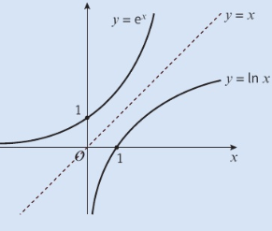 | Yr1 Chapter 9: Trigonometric ratios  Cosine rule  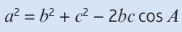  Sine rule for missing side  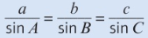  Sine rule for missing angle  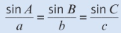  The sine rule sometimes produces two possible solutions for a missing angle: $sinθ=sin⁡(180°-θ)$  Area of triangles  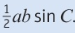  The graphs of sine, cosine and tangent are periodic. They repeat themselves after a certain interval.
Yr1 Chapter 10: Exact trigonometry values  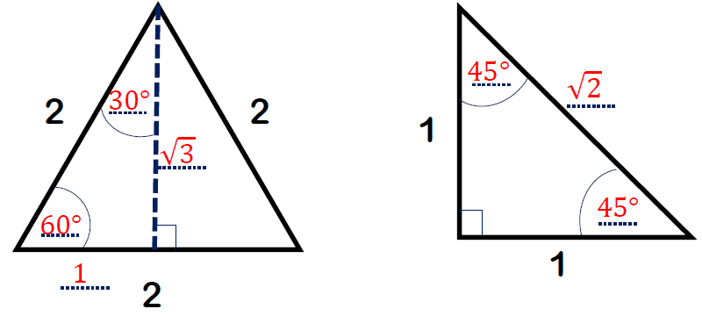  Trigonometric Identities  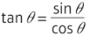 | Yr1 Chapter 12: Sketching gradient functions  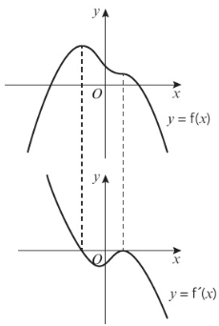
Yr2 Chapter 6: Trigonometric functions  Reciprocal trigonometric functions  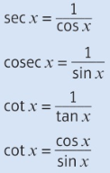  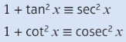  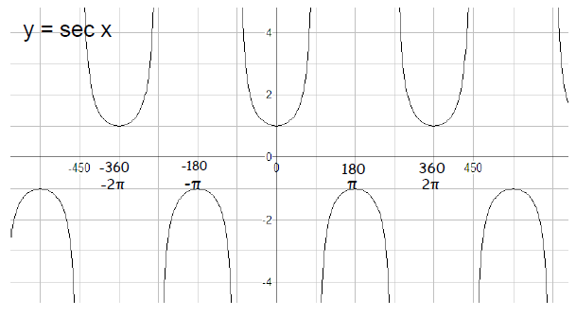  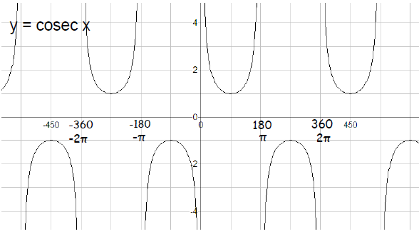  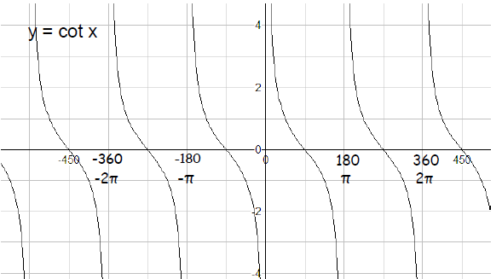 | Yr2 Chapter 6: Trigonometric functions  Inverse trigonometric functions  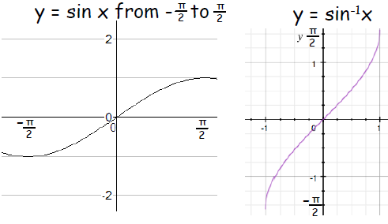  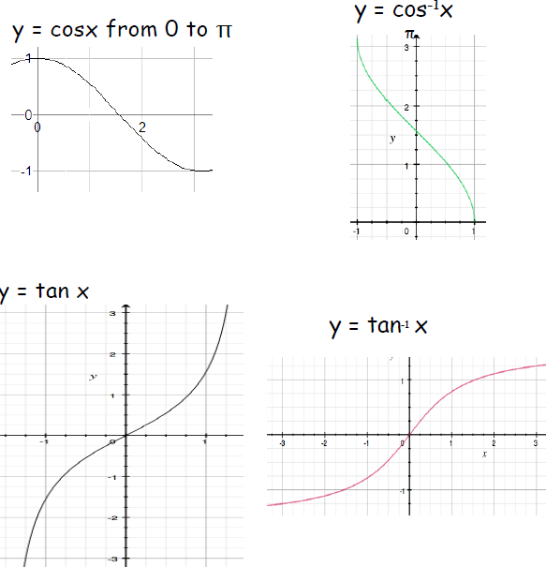
Yr1 Chapter 13: Integration-Areas between curves and lines  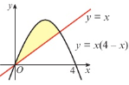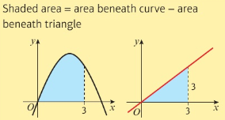  When the area bounded by a curve and the x-axis is below the x-axis, $\int{y}$ dx gives a negative answer | Yr2 Chapter 3: Convergent & divergent  Convergent series – The terms of the series are getting smaller and the sum of the series gets closer and closer to a finite number $\left|r\right|<1$  Divergent series – The terms of the series are getting larger and the sum of the series tends to infinity
Yr2 Chapter 9: Differentiation  Chain Rule: $\frac{dy}{dx}=\frac{dy}{du} ×\frac{du}{dx}$  $$\frac{dy}{dx}=\frac{1}{\frac{dx}{dy}}$$  Product Rule: $\frac{dy}{dx}=u\frac{dv}{dx}+v\frac{du}{dx}$  Parametric Equations: $\frac{dy}{dx}=\frac{\frac{dy}{dt}}{\frac{dx}{dt}}$  $y=e^{x},$ $\frac{dy}{dx}=e^{x}$  $y=e^{kx},$ $\frac{dy}{dx}={ke}^{kx}$  $y=lnx,$ $\frac{dy}{dx}=\frac{1}{x}$  $y=a^{x},$ $\frac{dy}{dx}=a^{x} ln a$  $y=a^{kx},$ $\frac{dy}{dx}=a^{kx}k ln a$  $y=sin x,$ $\frac{dy}{dx}=cos x$  $y=sin kx,$ $\frac{dy}{dx}=k cos kx$  $y=cos x,$ $\frac{dy}{dx}=-sin x$  $y=cos kx,$ $\frac{dy}{dx}=-k sin kx$  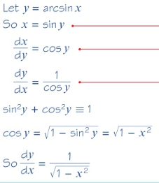  Implicit Differentiation  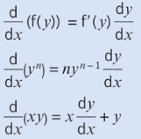  Concave when $f^{''}≤0$  Convex when $f^{''}≥0$ | Yr1 Chapter 7 & Yr2 Chapter 1: Mathematical proof  -State assumptions  -Show every step  -Write a statement at the end  Proof by exhaustion  E.g. Prove that all square numbers are either a multiple of 4 or 1 more than a multiple of 4. Consider the two cases, odd and even numbers separately and prove each case.  Proof by counter-example  E.g. The sum of two consecutive prime numbers is always even. Prove the mathematical statement is not true by showing one example that does not work for the statement.  Proof by deduction  Prove a mathematical statement is true by starting from known facts or definitions. Use logical steps to reach the desired conclusion.  Proof by contradiction  Assume the mathematical statement is not true. Show that this assumption leads to something impossible. Conclude that assumption was incorrect and original statement was true.  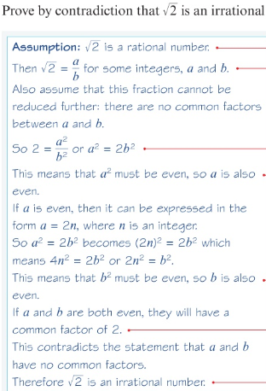
Yr 2 Chapter7: Trigonometry  Double angle formulae  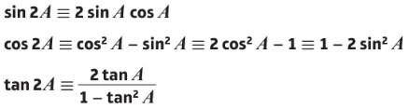  Express $2cosθ+5sinθ$ in the form $Rcos(θ-α)$  Use addition formulae  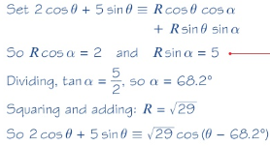 | Yr2 Chapter 8: Parametric equations example  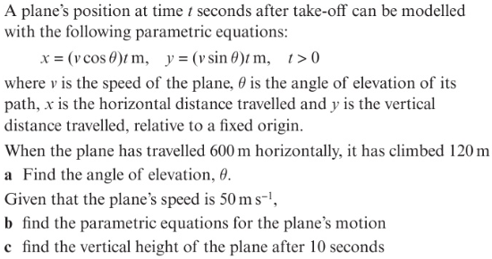  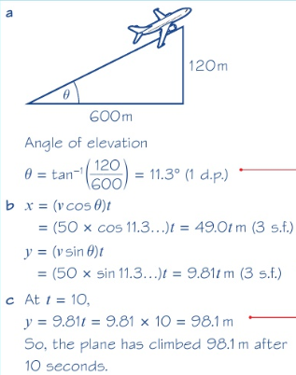
Yr1 Chapter 4: Important graphs
$y=√x$ $y=\frac{1}{x}$ $y=\frac{1}{x^{2}}$
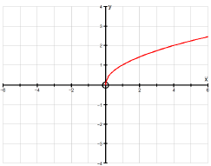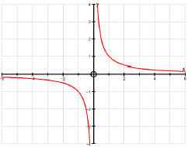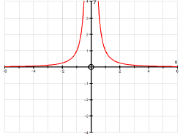
Yr2 Chapter 1: Partial Fractions  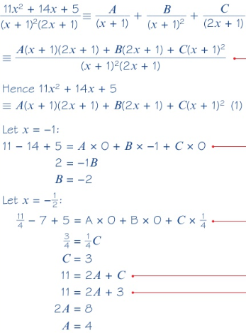 | Yr1 Chapter 7: Dividing polynomials  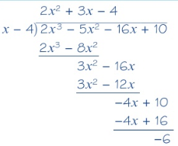
Yr2 Chapter 4: Binomial series for fractions and negatives

When n is negative or a fraction:
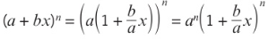
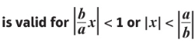

Formulae given to you in the exam:
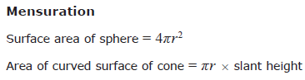  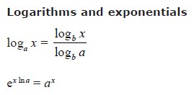 | 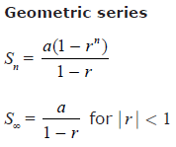
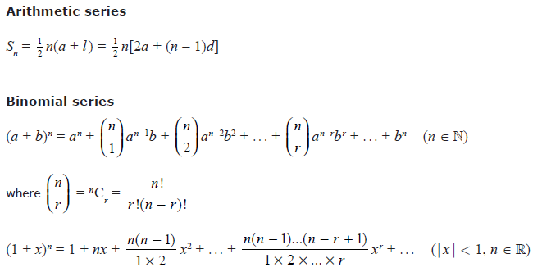
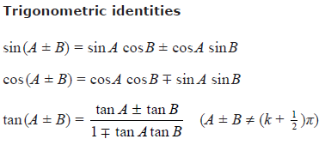  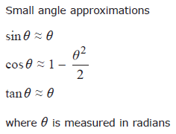 | 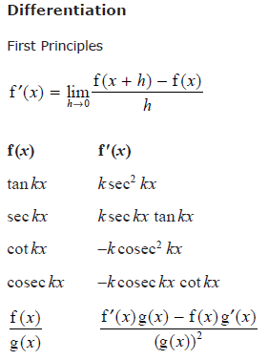
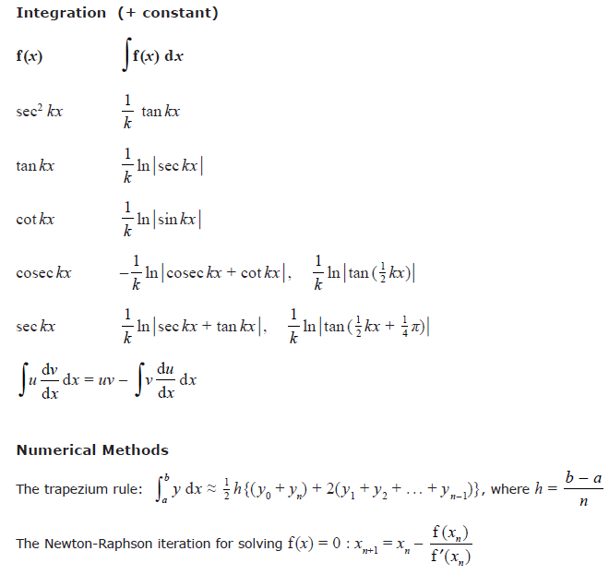

Additional key points to remember:

Pre 2018 Edexcel Core papers to the new A level Edexcel Pure Pearson Textbook

Core 1  Laws of indices – Y1 Ch1  Surds – Y1 Ch1  Quadratic functions and their graphs – Y1 Ch2  The discriminant – Y1 Ch2  Completing the square – Y1 Ch2  Simultaneous equations – Y1 Ch3  Linear and quadratic inequalities – Y1 Ch3  Algebraic manipulation of polynomials – Y1 Ch7  Graphs of functions – Y1 Ch4  Transformations of graphs – Y1 Ch4  Coordinate geometry – Y1 Ch5  Arithmetic sequences – Y2 Ch3  Basic Differentiation – Y1 Ch12  Basic Integration – Y1 Ch13 | Core 2  Algebraic division and factor theorem – Y1 Ch7 (do not need to know the Remainder Theorem)  Equation of a circle and circle properties – Y1 Ch6  Geometric sequences – Y2 Ch3  Binomial expansion – Y1 Ch8  The sine and cosine rules, ½ ab sin C – Y1 Ch9  Arc length and area of a sector in radians – Y2 Ch5  Trig graphs and solving trig equations – Y1 Ch10  Trig identities – Y1 Ch10  Exponential graphs – Y1 Ch14  Laws of logarithms – Y1 Ch14  Differentiation – stationary pts, inc/dec functions – Y1 Ch12  Integration – definite integrals, area under a curve – Y1 Ch13  Trapezium rule – Y2 Ch11
Core 3  Algebraic fractions – Y2 Ch1  Domain and range of functions – Y2 Ch2  Composite and inverse functions – Y2 Ch2  The modulus function – Y2 Ch2  Secant, cosec and cot – Y2 Ch6  Inverse trig functions – Y2 Ch6  Trig identities – Y2 Ch6  Double angle formulae – Y2 Ch7  The exponential and its graph – Y1 Ch14  ln x and its graph – Y1 Ch14  Differentiating trig – Y2 Ch9  The chain rule – Y2 Ch9  The product rule – Y2 Ch9  The quotient rule – Y2 Ch9  Locating roots – Y2 Ch10  Iteration – Y2 Ch10 | Core 4  Partial fractions – Y2 Ch1  Parametric equations – Y2 Ch11  Binomial expansion - negative and fractional powers – Y2 Ch4  Parametric differentiation – Y2 Ch9  Exponential growth and decay – Y1 Ch14  Differential equations – Y2 Ch11  Reverse chain rule – Y2 Ch11  Integration by substitution – Y2 Ch11  Integration by parts – Y2 Ch11  Integration using partial fractions – Y2 Ch11  Numerical integration of functions – Y2 Ch11  Vectors – Y1 Ch11 & Y2 Ch12

New Topics for Edexcel in 2018 (Covered in OCR Core 3)
-Differentiation using the chain rule - problems involving connected rates of change and inverse functions

New Topics for Edexcel in 2018 (Covered in OCR Core 4)
-Differentiation using the product rule and the quotient rule - problems involving connected rates of change and inverse functions
-Iterative methods - Staircase and cobweb diagrams
-Exponential growth and decay - use in modelling
-Vectors - The scalar product and its use for calculating the angle between two planes and the angle between a line and a plane

Past paper guidance
-Past papers and mark schemes can be found here: https://www.smlmaths.com/past-papers-and-markschemes
-Complete past papers in timed exam conditions. DO NOT look at the mark scheme whilst doing the paper
-Highlight questions you need help with. Ask your teacher for help or attend a support session
-Mark your work honestly and write your mark in the tables above

Old Spec OCR A-Level Maths Past Papers
Past Papers | C1 Score | C2 Score | C3 Score | C4 Score | Topics to revisit
Jan-06
Jun-06
Jan-07
Jun-07
Jan-08
Jun-08
Jan-09
Jun-09
Jan-10
Jun-10
Jan-11
Jun-11
Jan-12
Jun-12
Jan-13
Jun-13
Jun-14
Jun-15
Jun-16
Jun-17

Edexcel A-Level Maths Practice Papers and Past Papers
Papers | AS-Level Score | A-Level Score | Topics to revisit
Practice Paper A
Practice Paper B
Practice Paper C
Practice Paper D
Practice Paper E | n/a
Practice Paper F | n/a
Practice Paper M | n/a
Practice Paper N | n/a
Practice Paper O | n/a
Practice Paper P | n/a
Practice Paper Q | n/a
Jun-18 |  | Paper 1:  Paper 2:
Jun-19 |  | Paper 1:  Paper 2:

