1 Find in exact form the unit vector in the same direction as a = 4i – 7j. (3 marks)
2 In, and. P divides OA in the ratio 3 : 2 and Q divides
OB in the ratio 3 : 2
a Show that PQ is parallel to AB. (4 marks)
b Given that AB is 10 cm in length find the length of PQ. (1 mark)
Figure 1
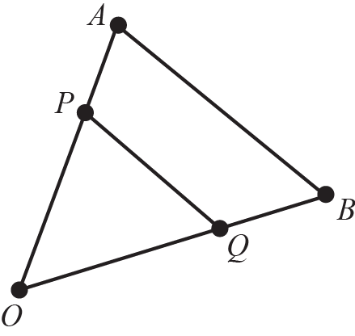
3 Given that the resultant of the vectors a = 2pi – 5j and b = 6i – 3pj is parallel
to the vector c = 4i – 5j, find
a the value of p (4 marks)
b the resultant of the vectors a and b. (2 marks)
4 Given that point A has the position vector 4i + 7j and point B has the position
vector 10i + qj, where q is a constant, find
a the vector in terms of q (2 marks)
b Given further that, find the two possible values of q showing
detailed reasoning in your working. (5 marks)
5 In , and
Figure 2
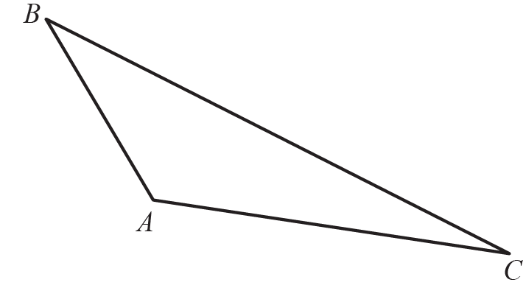
a Find the size of, in degrees, to 1 decimal place. (5 marks)
b Find the exact value of the area of . (3 marks)
6 A particle P of mass 6 kg moves under the action of two forces, F₁ and F₂,
where F₁ = (8i − 10j) N and F₂ = (pi + qj) N, p and q are constants. The acceleration of P is a = (3i – 2j) ms⁻²
a Find, to 1 decimal place, the angle between the acceleration and i. (2 marks)
b Find the values of p and q. (3 marks)
c Find the magnitude of the resultant force R of the two forces F₁ and F_{2.}
Simplify your answer fully. (3 marks)
7 OACB is a parallelogram. and. The points M, S, N and T divide OB, BC, CA and AO in the ratio 1 : 4 respectively. The lines ST and MN intersect at the point D.
Figure 3
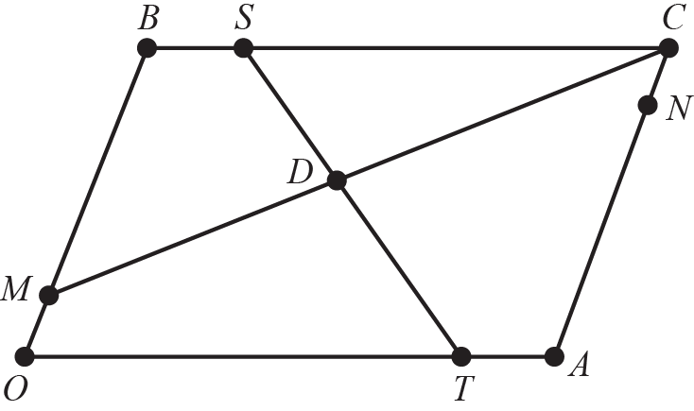
a Expressin terms of a and b. (2 marks)
b Expressin terms of a and b. (2 marks)
c Show that the lines MN and ST bisect one another. (9 marks)

