1 Find (5 marks)
2 The curve with equation y = h(x) passes through the point (4, 19).
Given that , find h(x). (6 marks)
3 a Given that, find the two possible values of a. (6 marks)
b Labelling all axes intercepts, sketch the graph of for (2 marks)
c With reference to the integral in part a and the sketch in part b, explain why the
larger value of a found in part a produces a solution for which the actual area under
the graph between a and 2a is not equal to 1 and state whether the area is greater
than 1 or smaller than 1. (2 marks)
4 The speed, v ms⁻¹, of a rollercoaster at time t s is given by
The distance, s m, travelled by the rollercoaster in the first 20 s is given
by
Find the value of s, giving your answer to 3 significant figures. (5 marks)
5 The graph shows part of the curve C with equation
Figure 1

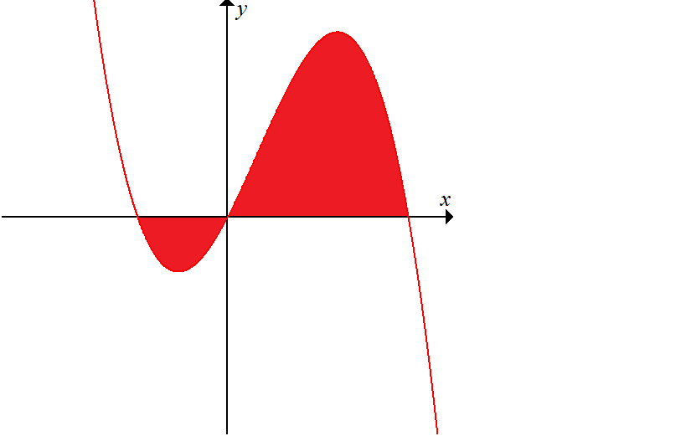
The curve C crosses the x-axis at the origin O and at points A and B.
a Using an appropriate algebraic method, find the coordinates of A and B. (3 marks)
b The finite region shown shaded is bounded by the curve C and the x-axis.
Use calculus to find the total area of the shaded region. (8 marks)
6 The diagram shows part of curve with equation and part of the line
with equation
Figure 2

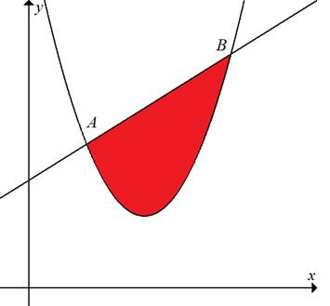

a Using an appropriate algebraic method, find the coordinates of A and B. (4 marks)
The x-coordinates of A and B are denoted x_{A} and x_{B} respectively.
b Find the exact value of the area of the finite region bounded by the x-axis, the lines
x = x_{A} and x = x_{B} and the line AB. (2 marks)
c Use calculus to find the exact value of the area of the finite region bounded by the
x-axis, the lines x = x_{A} and x = x_{B} and the curve (5 marks)
d Hence, find, to one decimal place, the area of the shaded region enclosed by the
curve and the line AB. (2 marks)

