**Year 12 Applied Maths Homework Booklet**

**Name:____________________________________**

**Maths Teachers:____________________________**

**Contents**

**Page 2:** Data Collection

**Page 6:** Measures of Location and Spread

**Page 9:** Representations of Data

**Page 13:** Correlation

**Page 16:** Probability

**Page 20:** Statistical Distributions

**Page 24:** Hypothesis Testing

**Page 27:** Modelling in Mechanics

**Page 30:** Constant Acceleration

**Page 38:** Forces and Motion

**Page 44:** Variable Acceleration

**Data Collection**

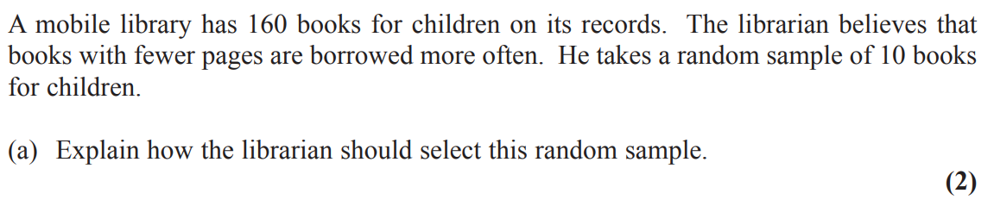**1**

**2**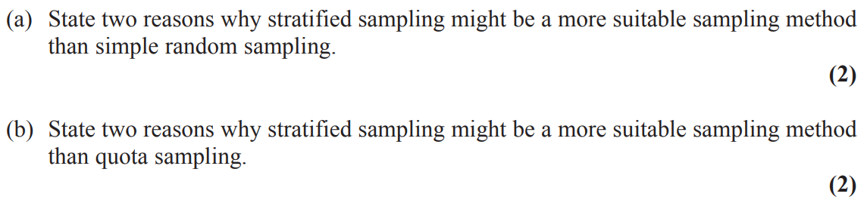

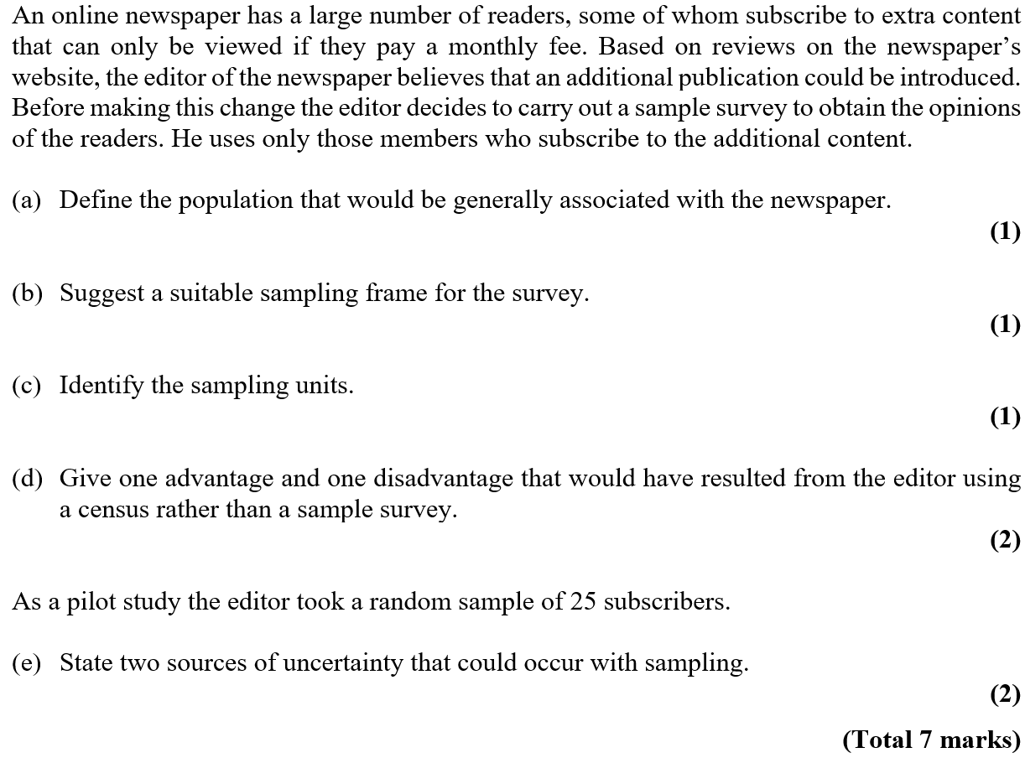**3**

**4**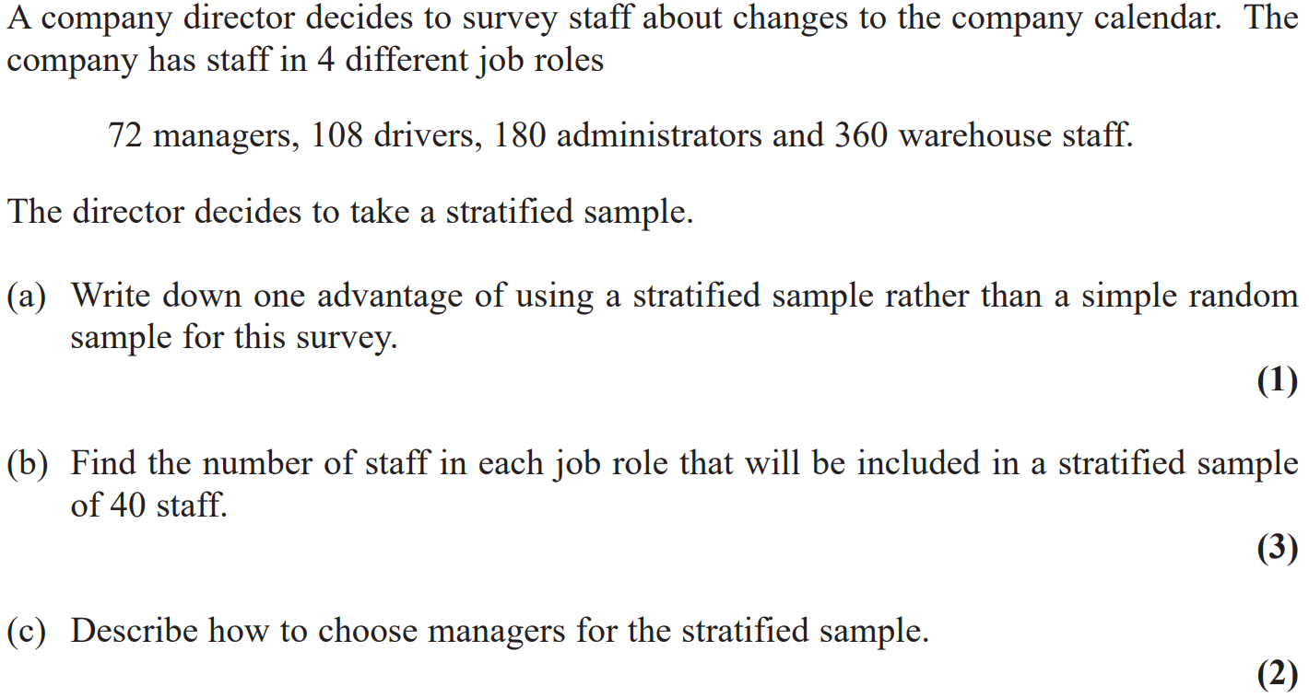

**5**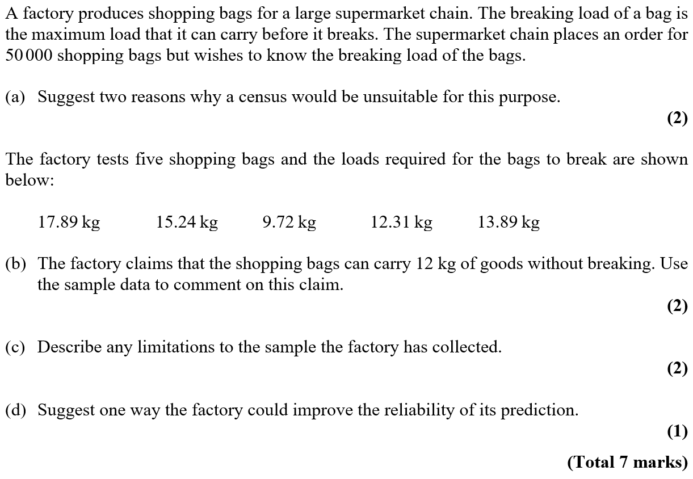

**Measures of Location of Spread**

**1**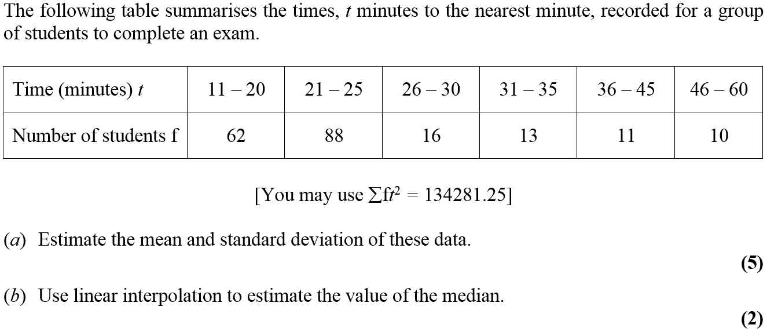

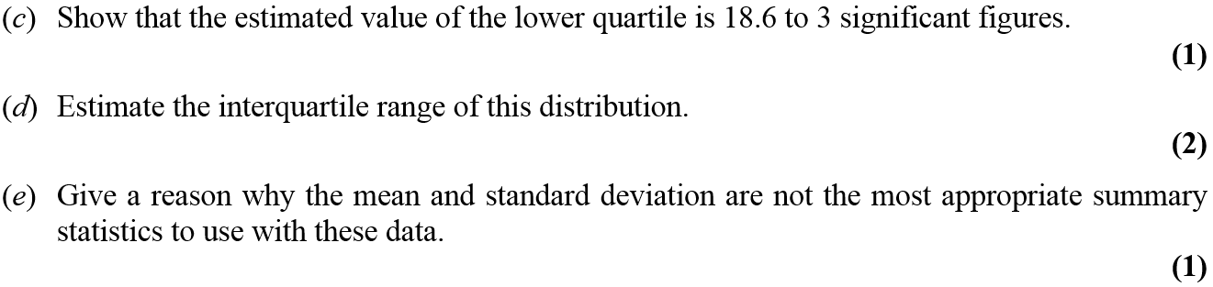

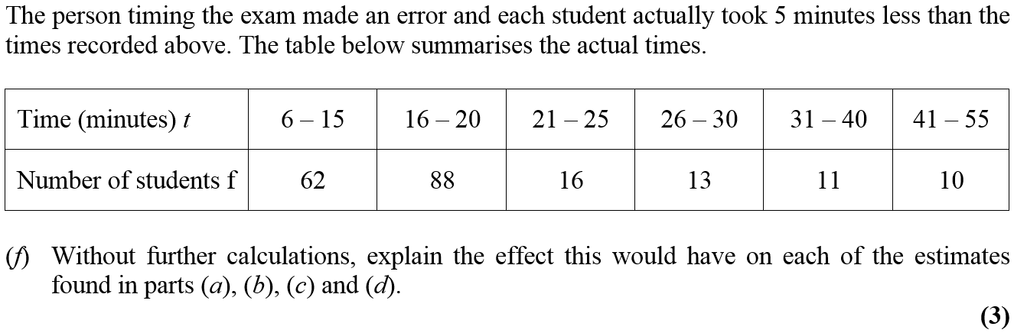

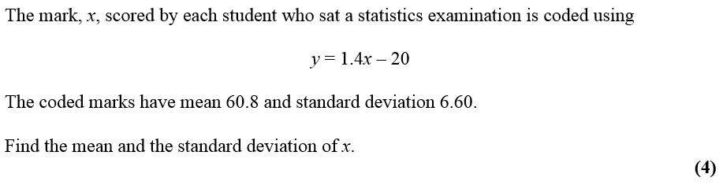**2**

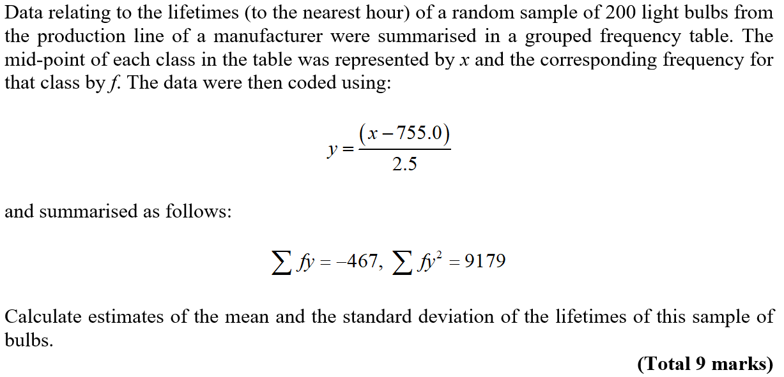**3**

**Representations of Data**

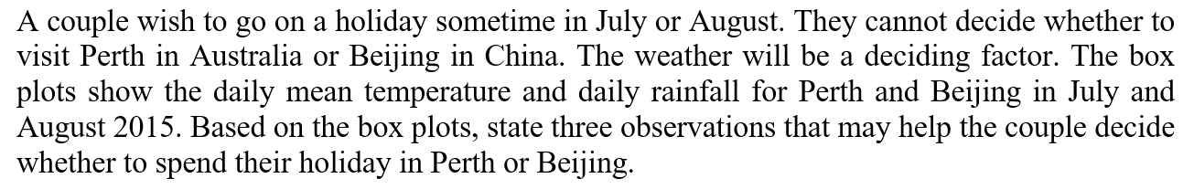**1**

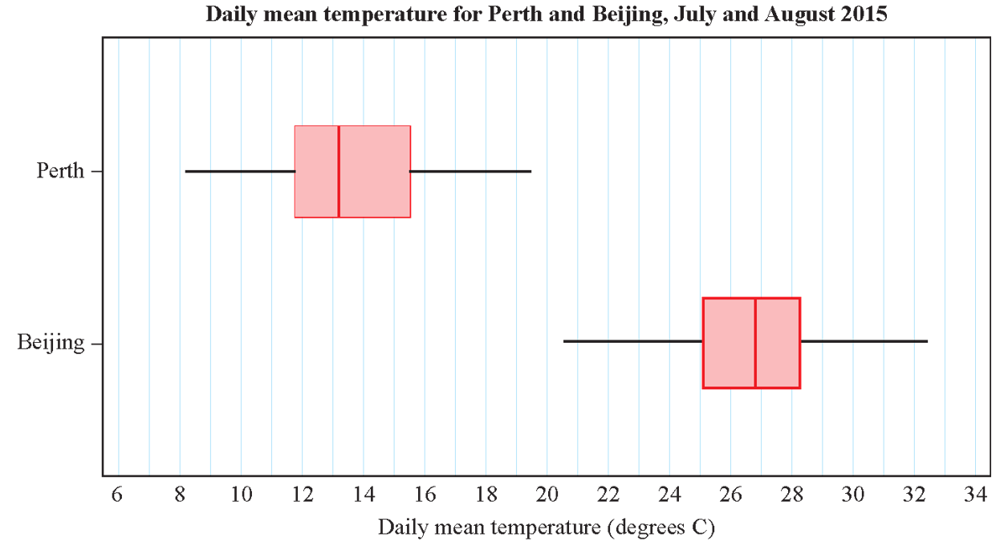

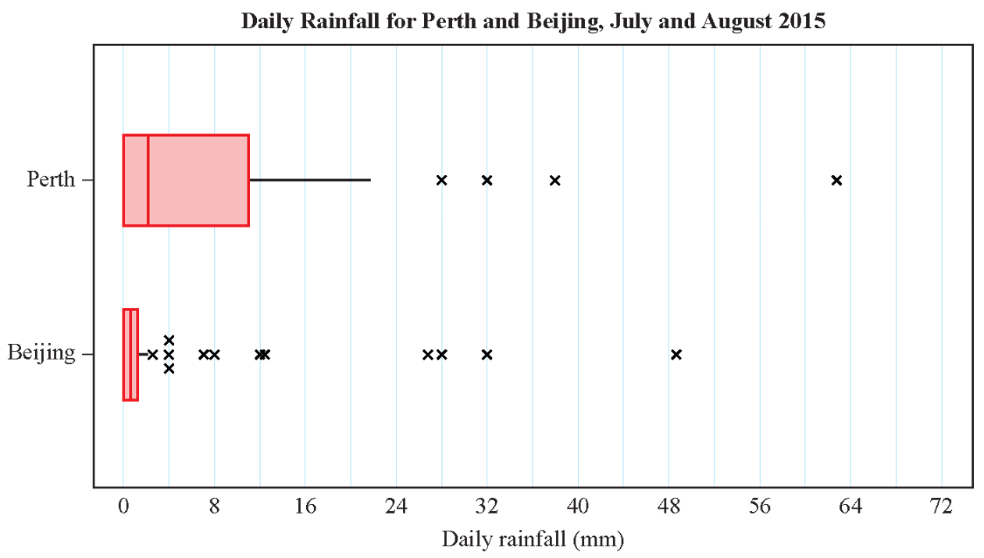

**2**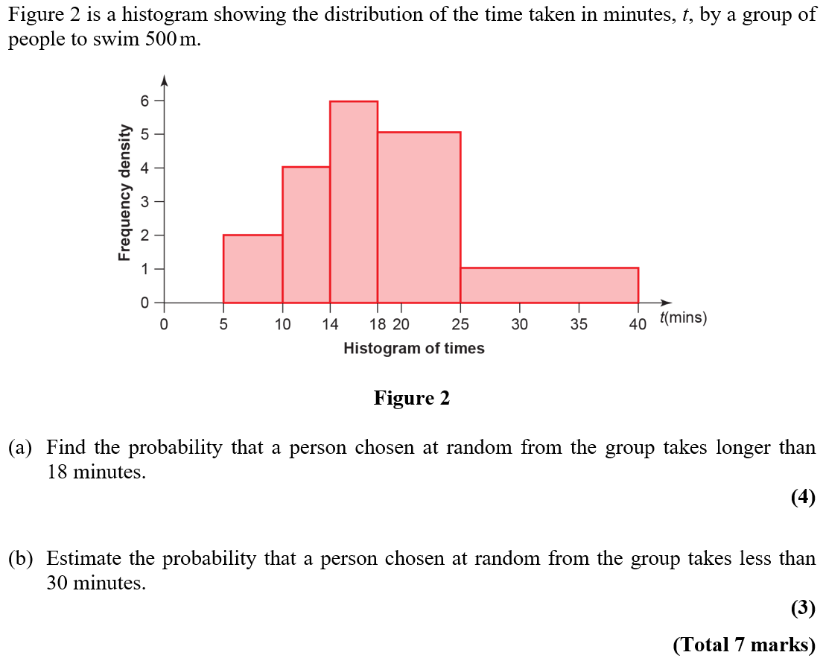

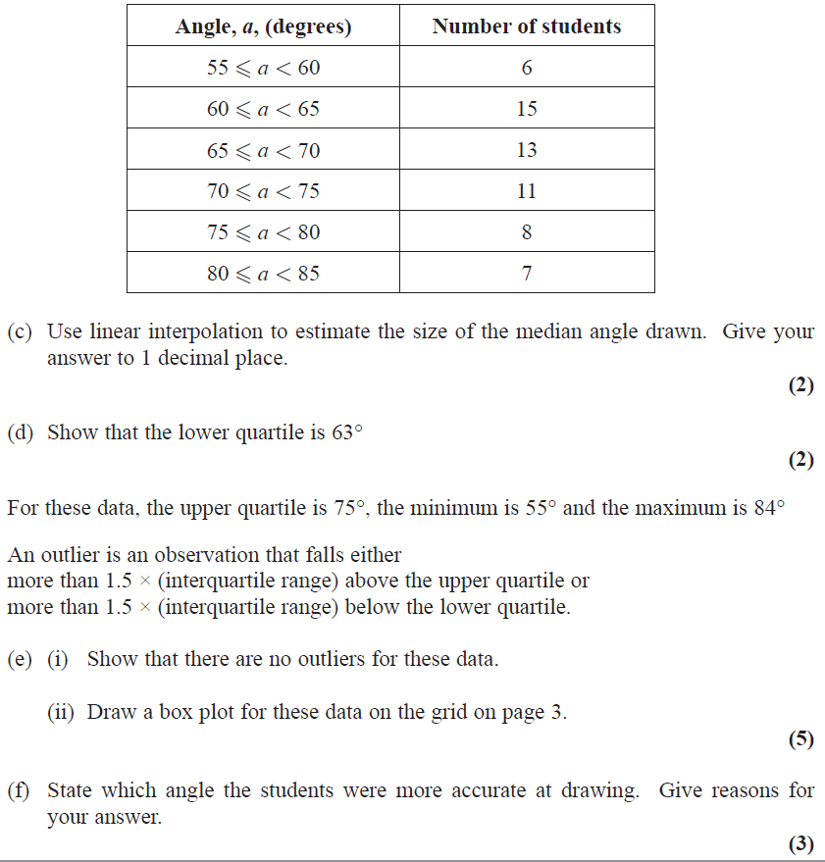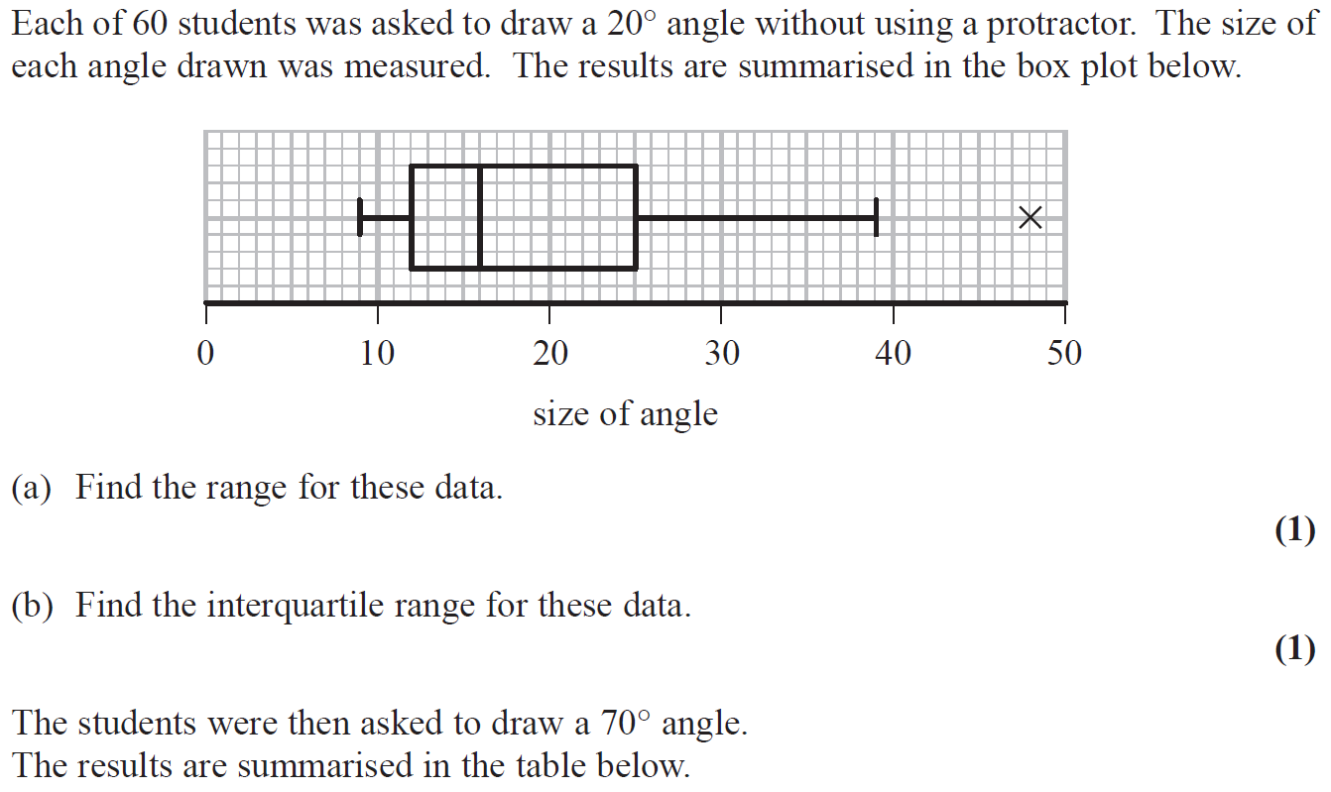**3**

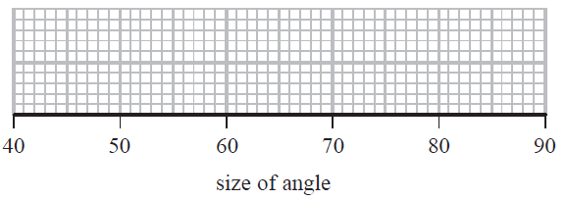

**Correlation**

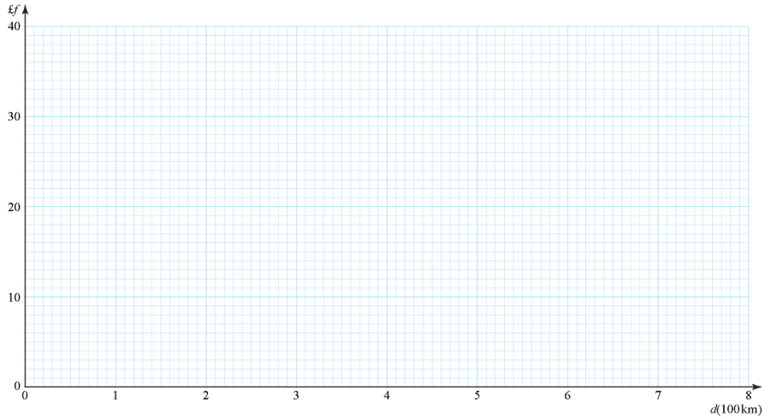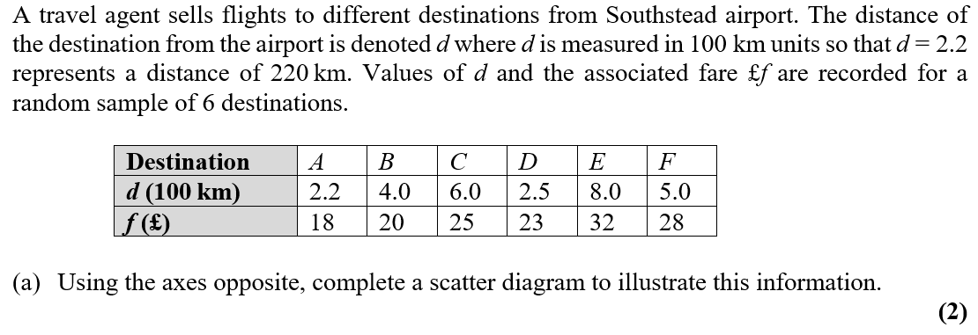**1**

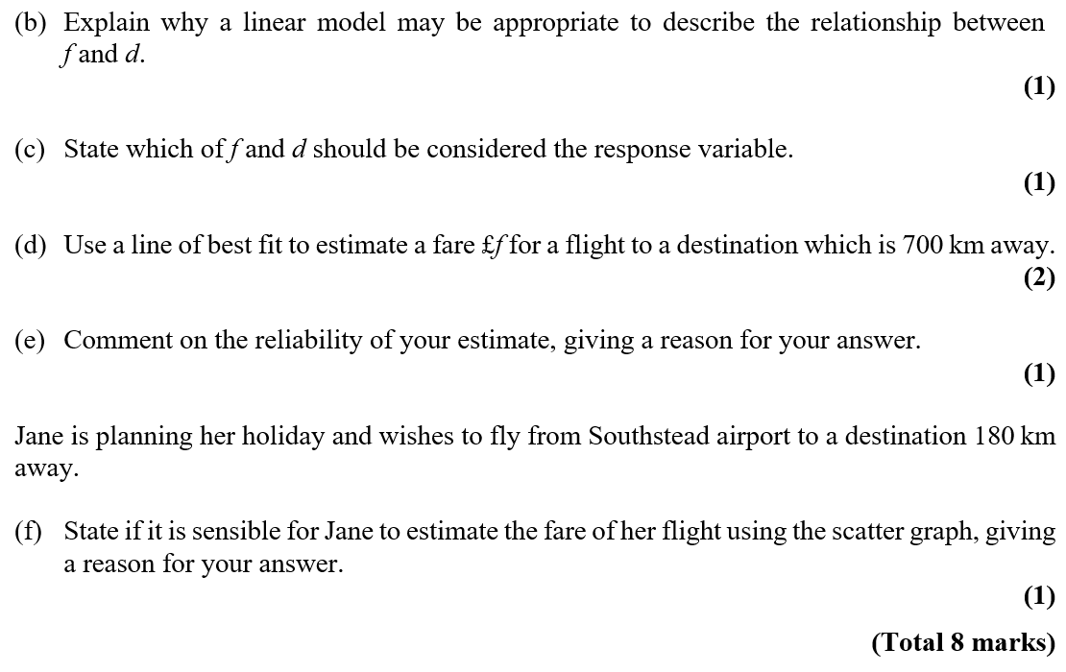

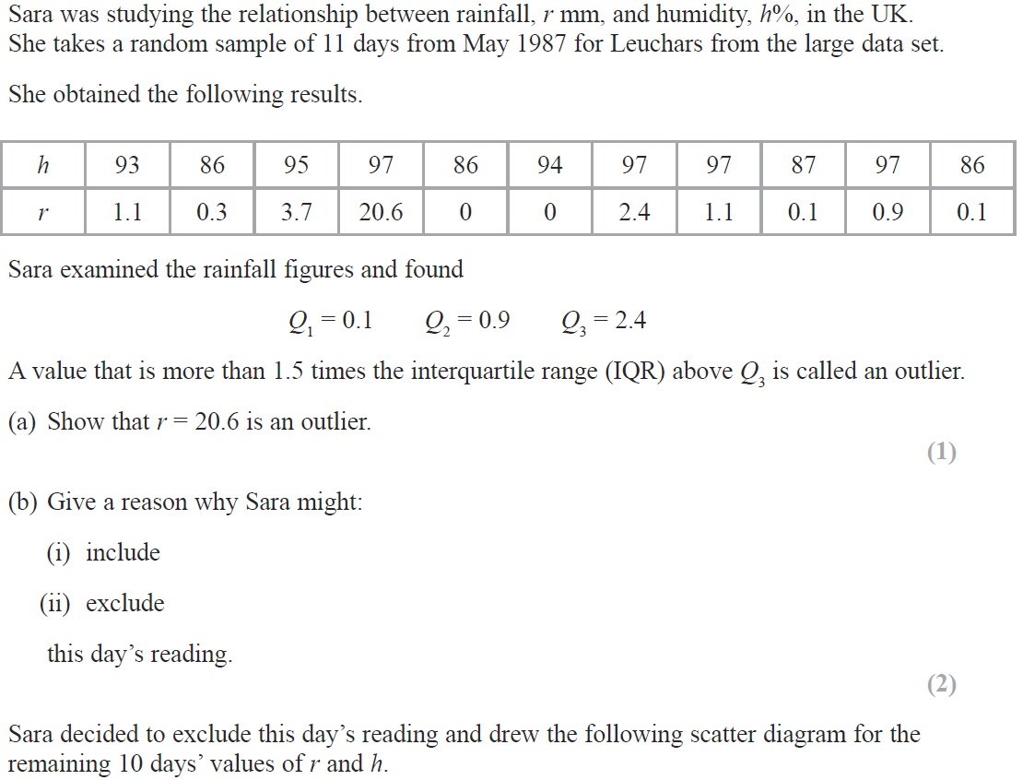**2**



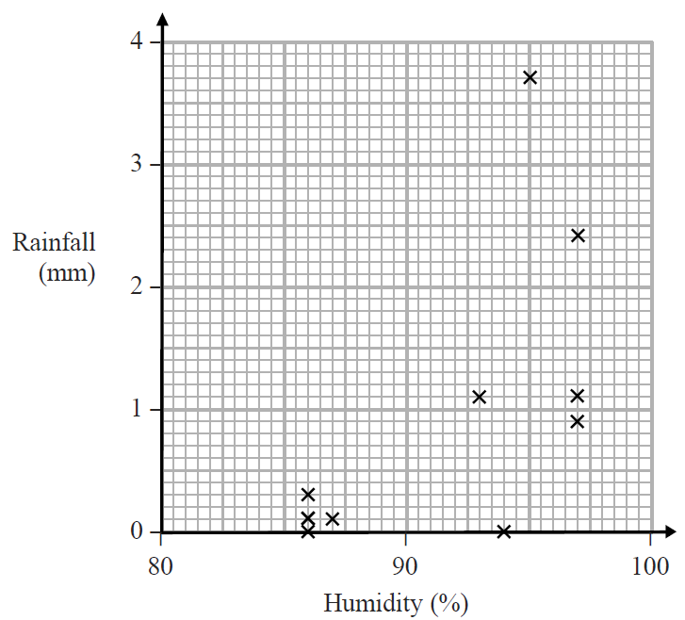



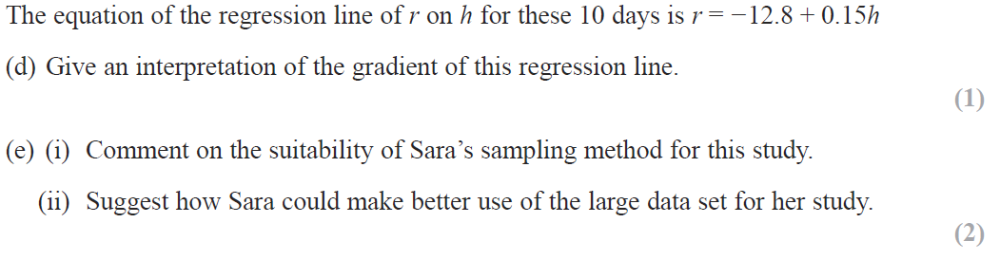

**Probability**

**1**

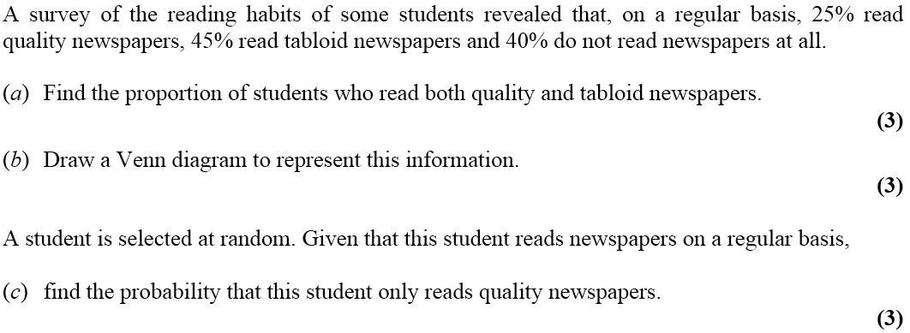

**2**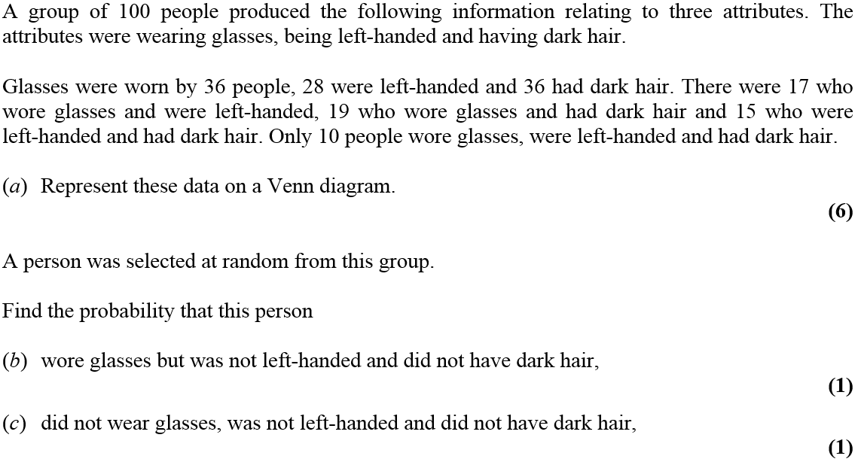

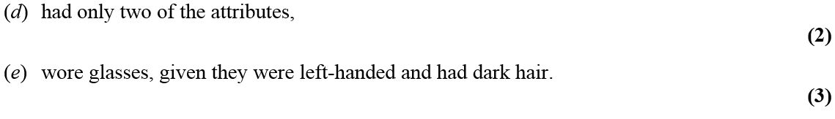

**3**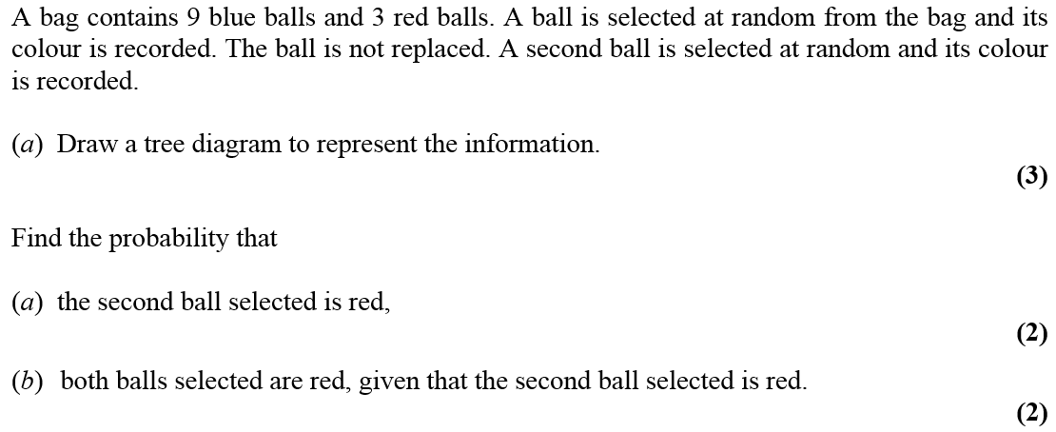

**4**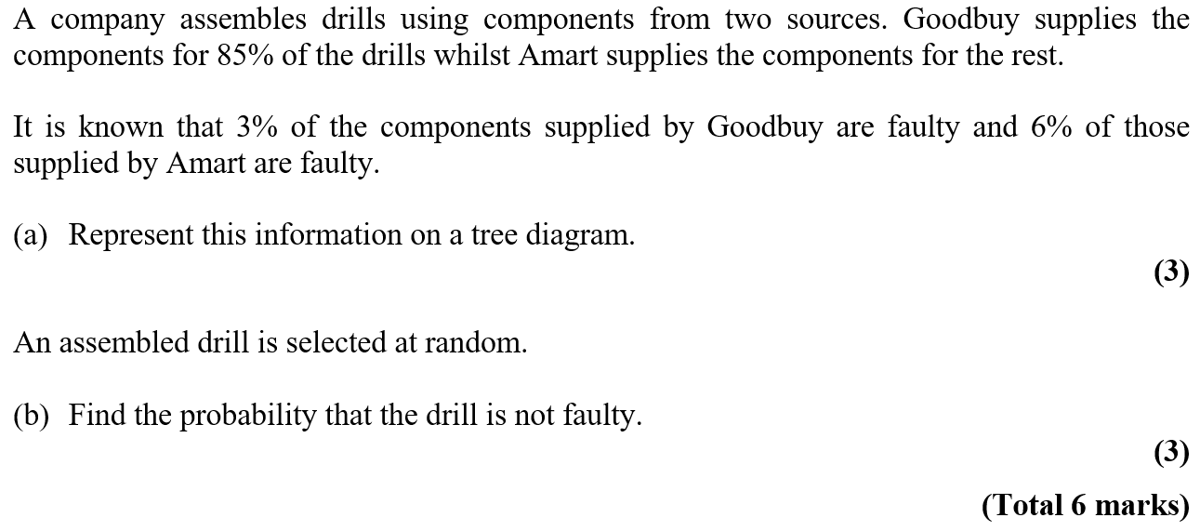

**Statistical Distibutions**

**1** 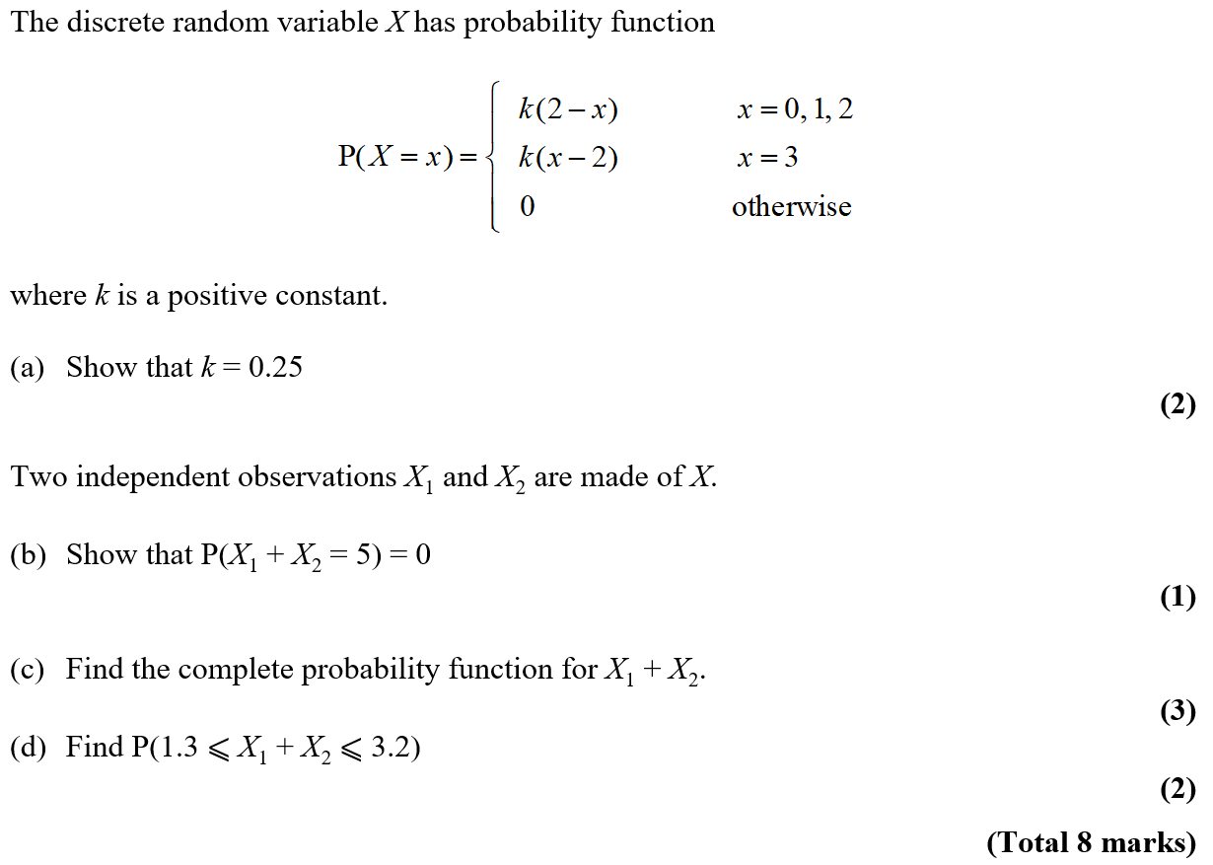

**2** 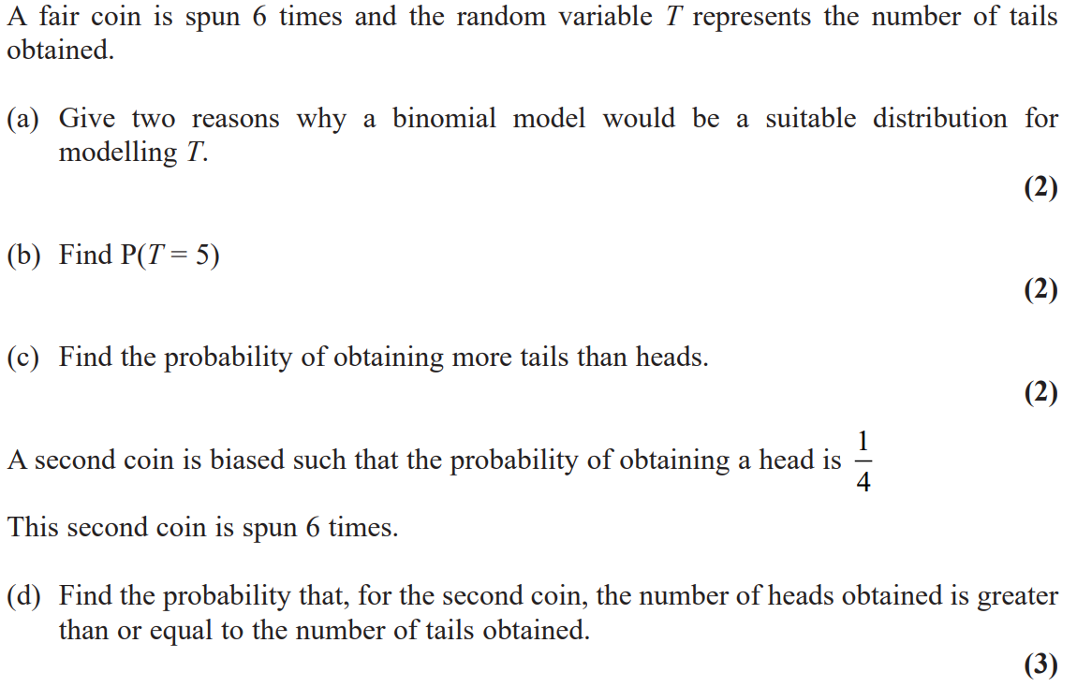

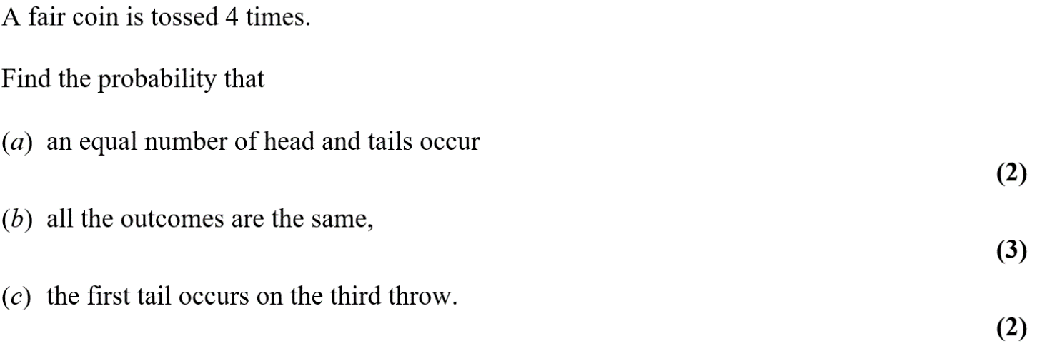**3**

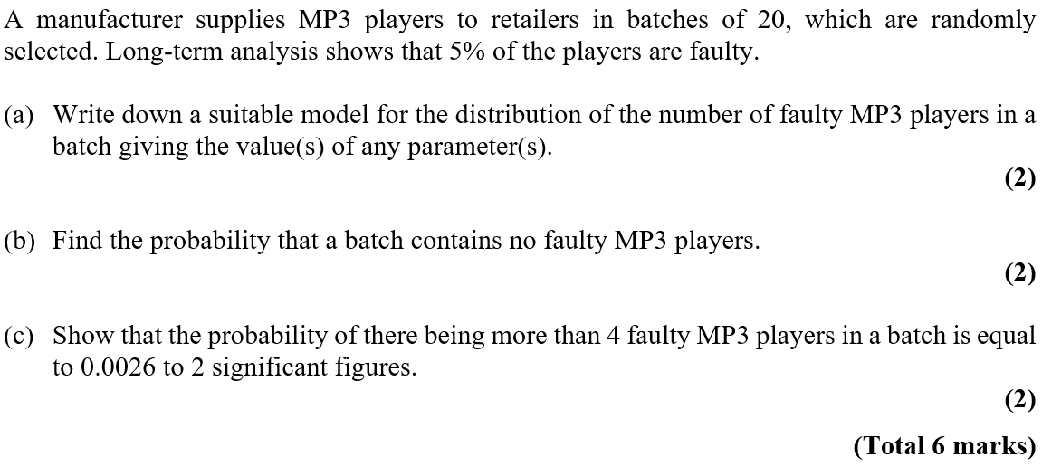

**4**

**Hypothesis Testing**

**1** 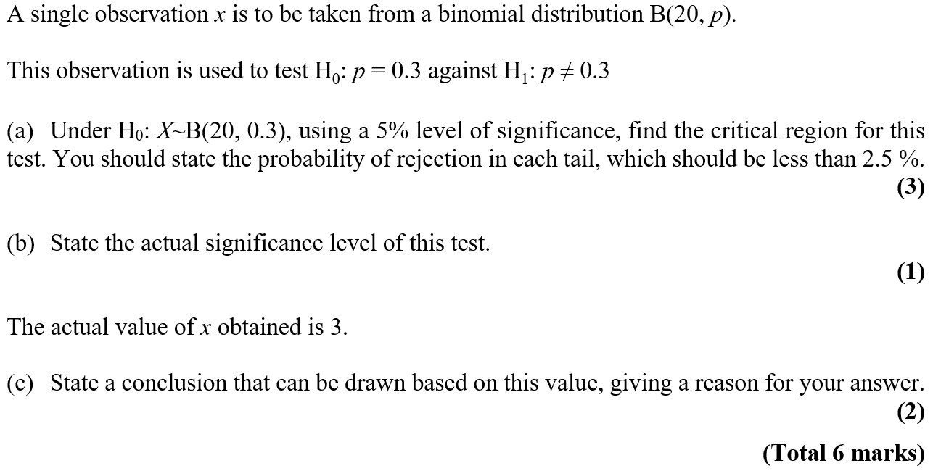

**2** 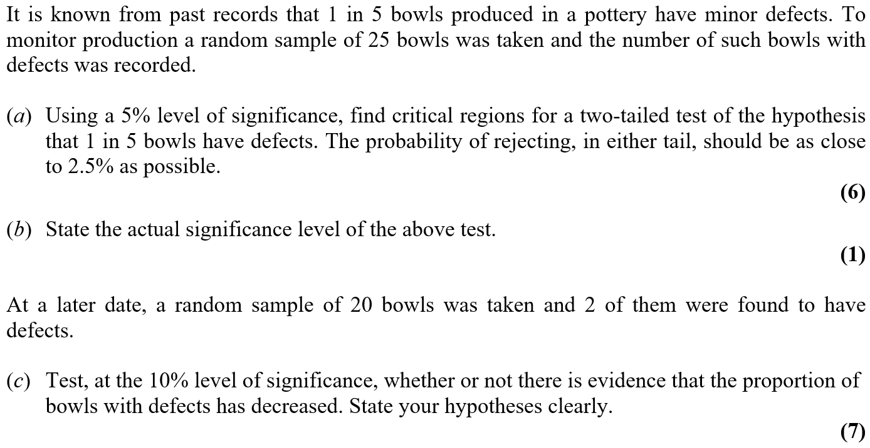

**3** 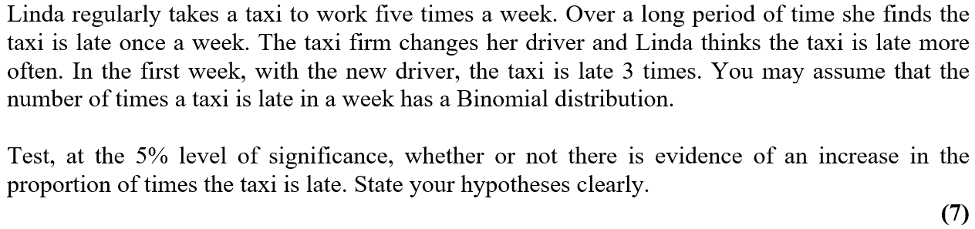

**Modelling in Mechanics**

**1** 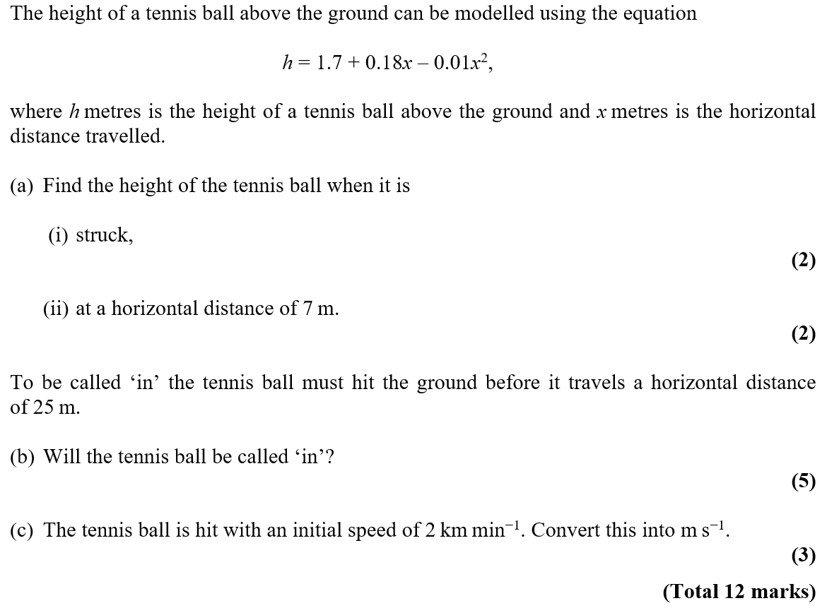

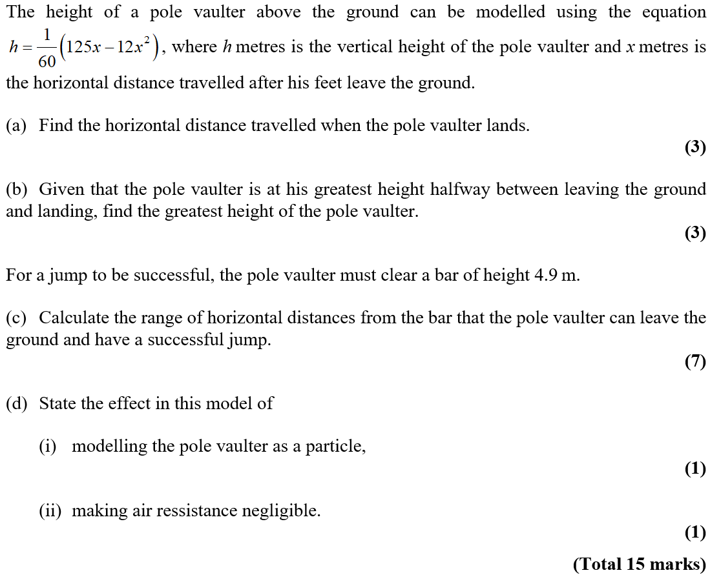**2**

**Constant Acceleration**

**1** 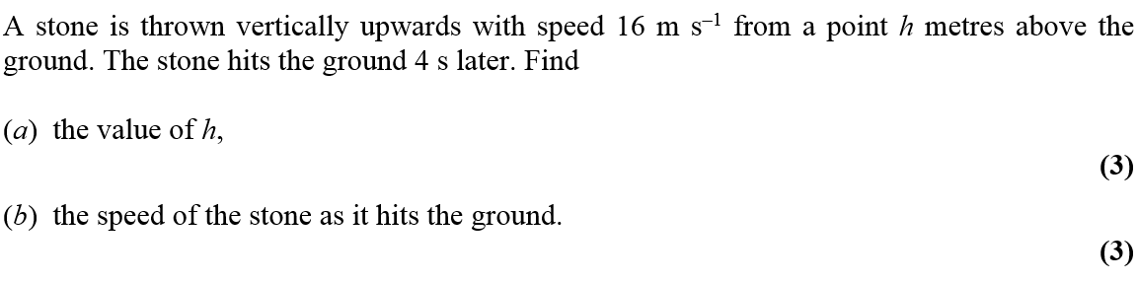

**2** 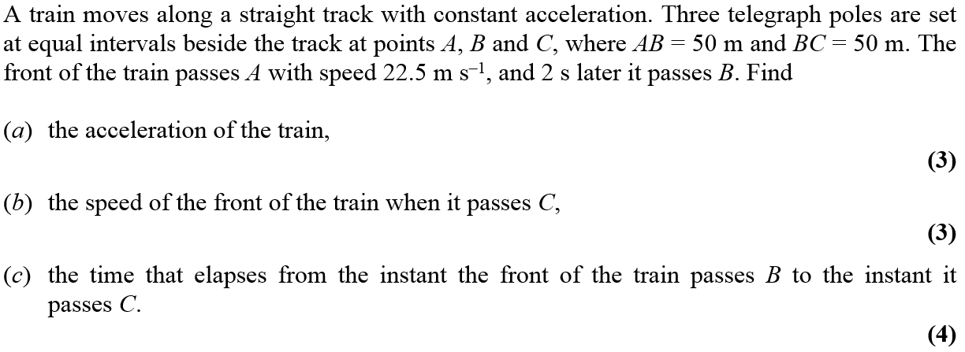

**3**

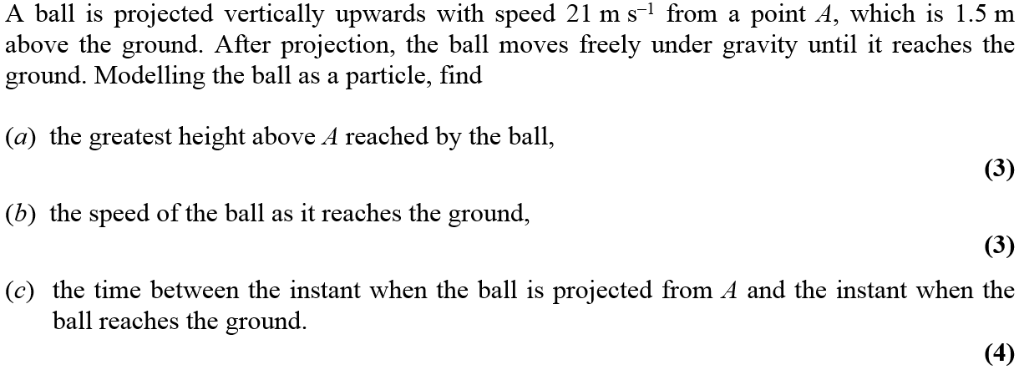

**4** 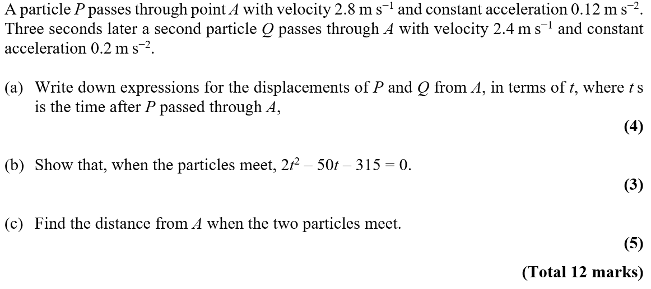

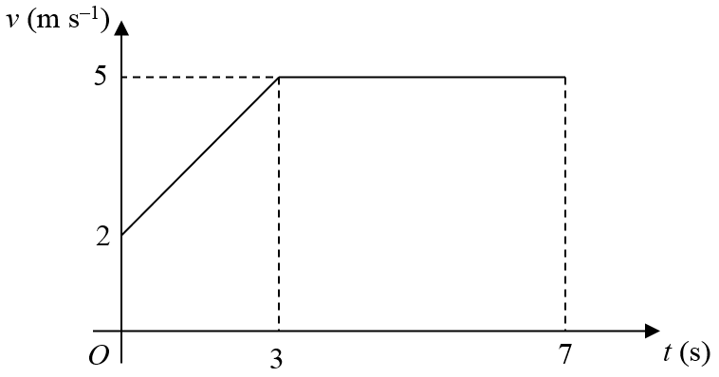**5**

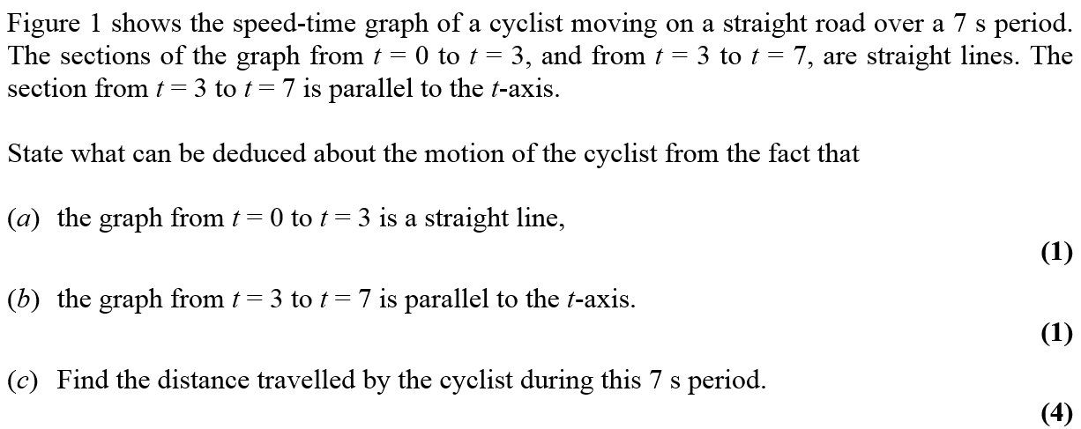

**6** 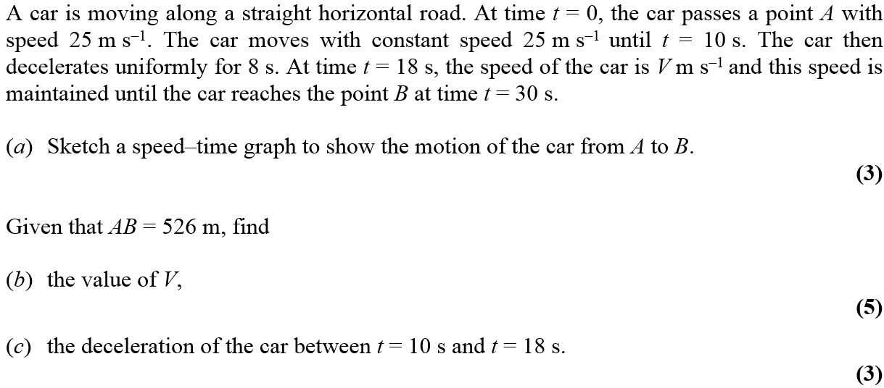

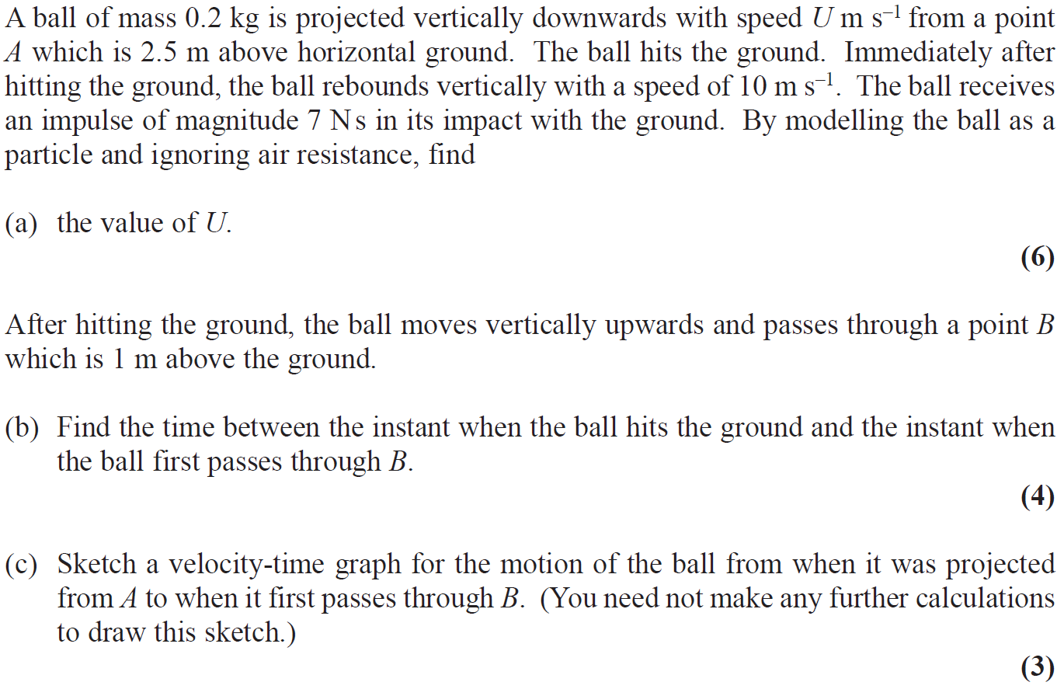**7**

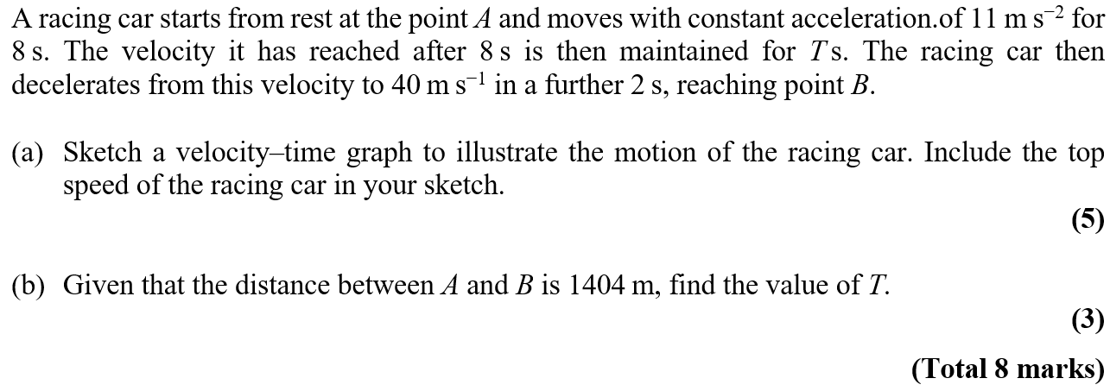

**8**

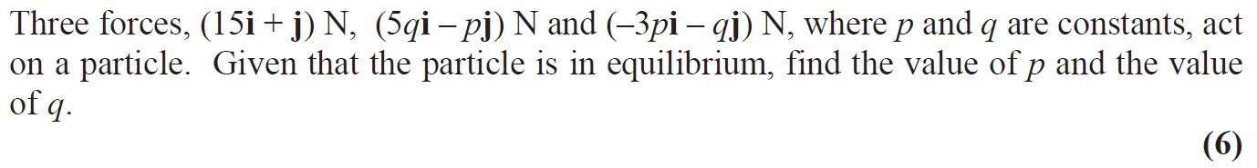**Forces and Motion**

**1**

**2** 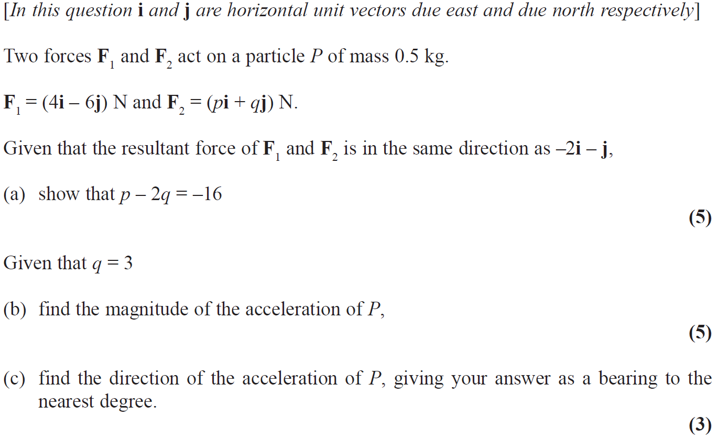

**3** 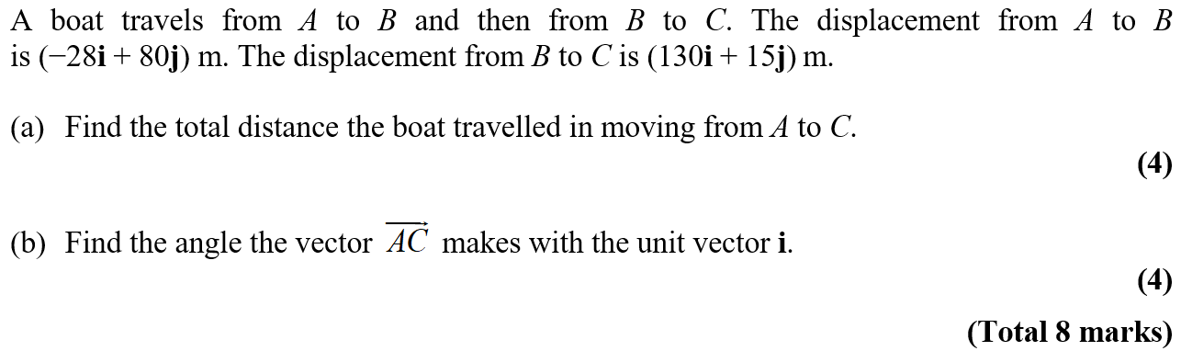

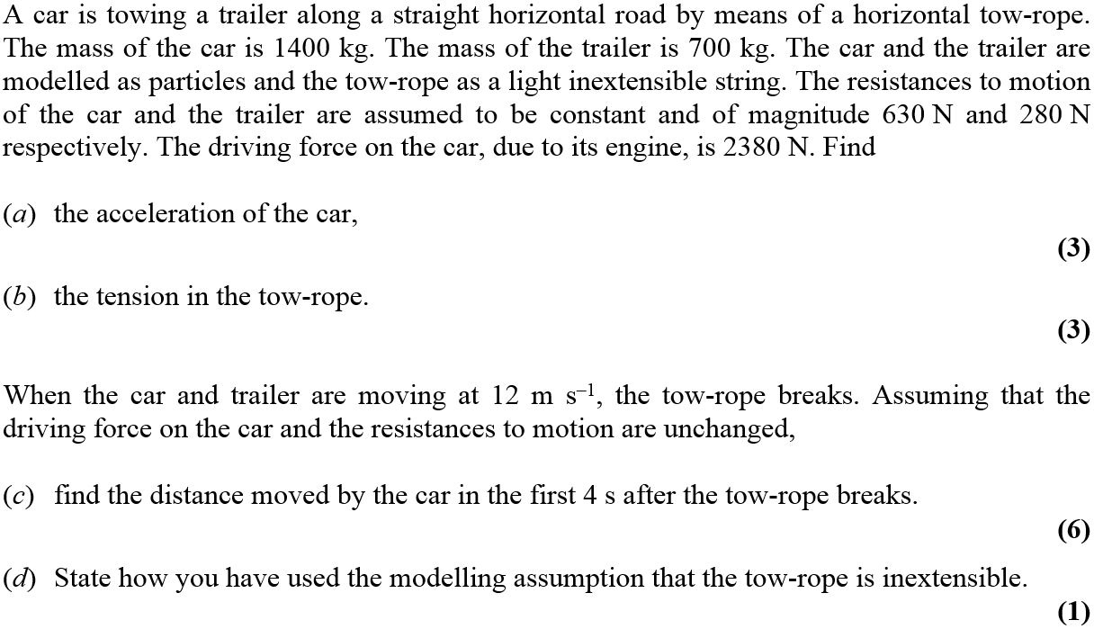**4**

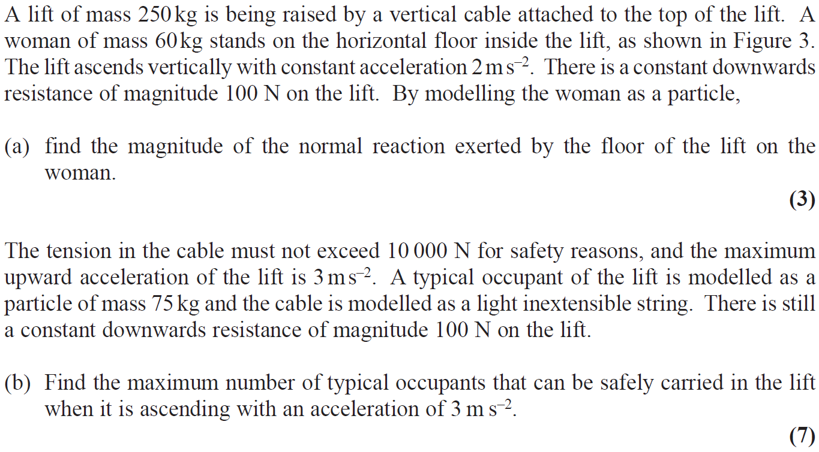**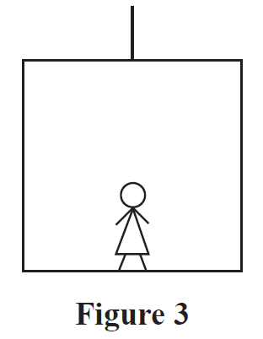5**

**Variable Acceleration**

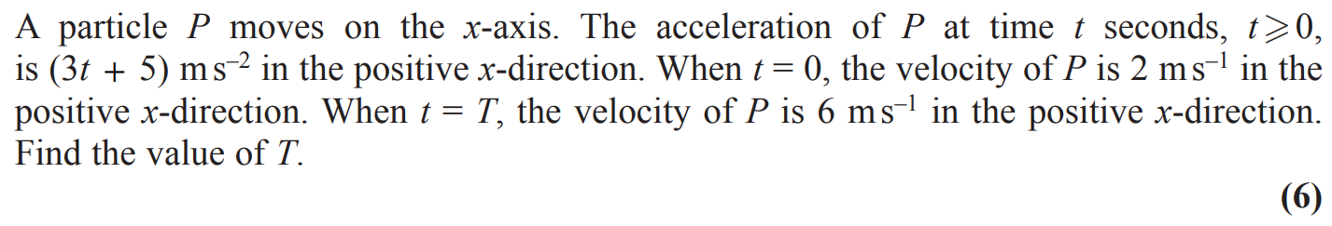**1**

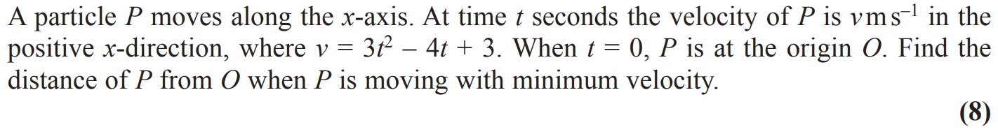**2**

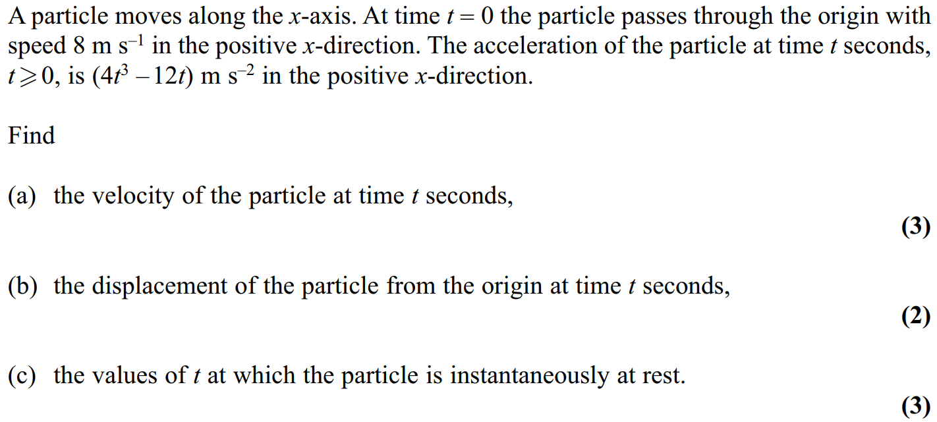**3**

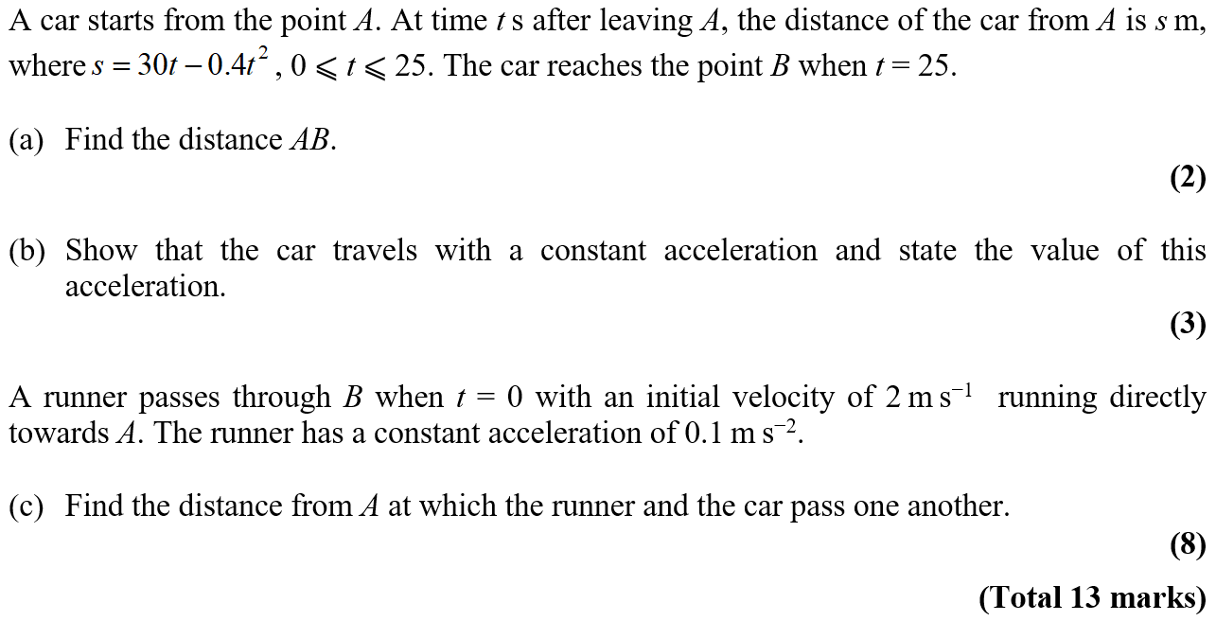**4**